LAB 2 OUTPUTS

Q1. Write a C# program to add two digit using delegates.

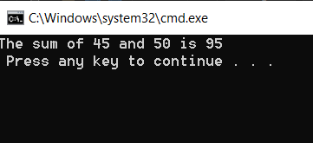

Q2. Write a C# program to Add, Subtract, Multiply, Divide using OOP.

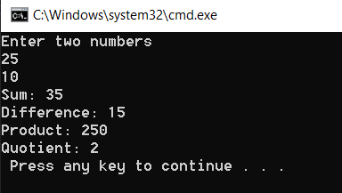

Q3. Write a C# program to Add, Subtract, Multiply, Divide using Interface.

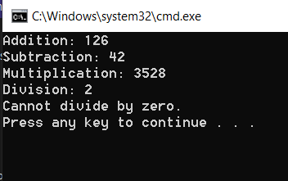

Q4. Write a C# program to print 1 to 10 using generic list.

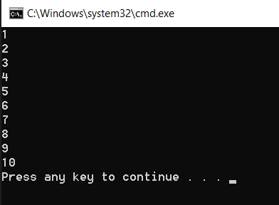

Q5. Write a C# program to print CustomerId and CustomerName using Dictionary.

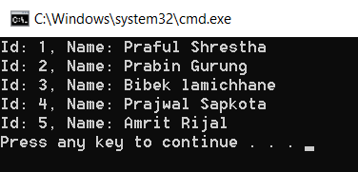

Q6. Write a C# program to sort given name using LINQ.

a. Ram,Shyam,Hari,Bikash,Mahesh

